**Using Interactive Technology to Teach Basic Algorithmic Instructions (Wanda) – Step-by-Step**

1. A screenshot of a video game

   Description automatically generatedTo connect to Cozmo, you must connect to the robot through a Wi-Fi connection then click on the Connect button.
2. A screenshot of a video game

   Description automatically generatedOnce the Cozmo is connected, scroll to the left to Code Lab
3. A screenshot of a computer

   Description automatically generatedClick on new Sandbox Project
4. A screenshot of a computer

   Description automatically generatedA blank sandbox should be seen with code blocks on the bottom. Go to “Drive” and select the block with the 2 arrows
5. This section will show you how to make Cozmo move in a square. Under the “Drive” tab, select the first code block. Attach it to the green flag and change the number to 4.

1. 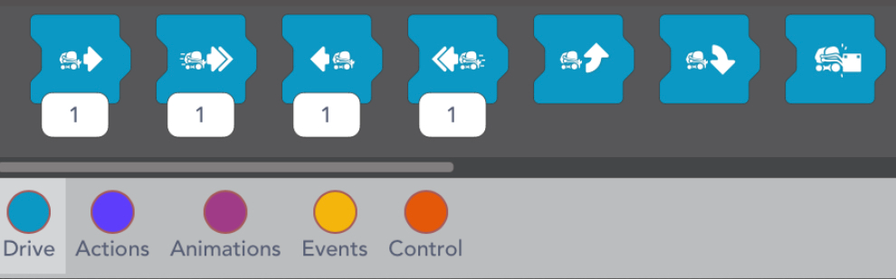Under the “Drive” tab select the following code block and attach it to the end of the code.
2. 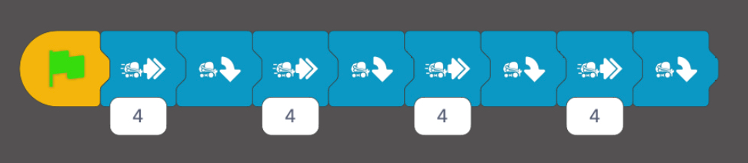Repeat this process until the code look like the one below.
3. 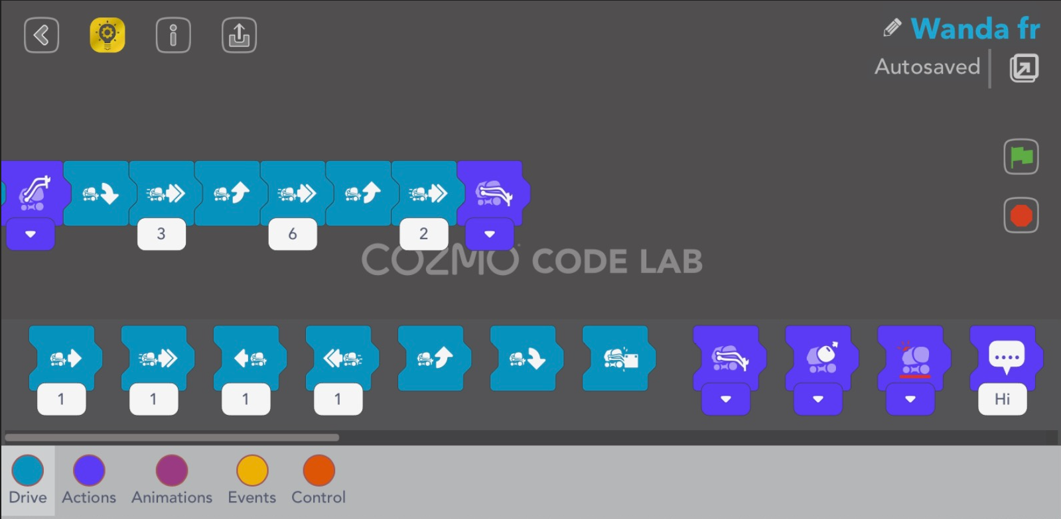To test the code, click on the green flag. To stop the code while it is running, click on the red stop sign.
4. 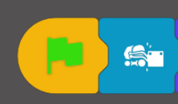This section will show you how to make Cozmo look for the cube, pick up the cube, and place it down at a new location. Select the “Drive” tab and grab the code block shown below. Attach it to the green flag.

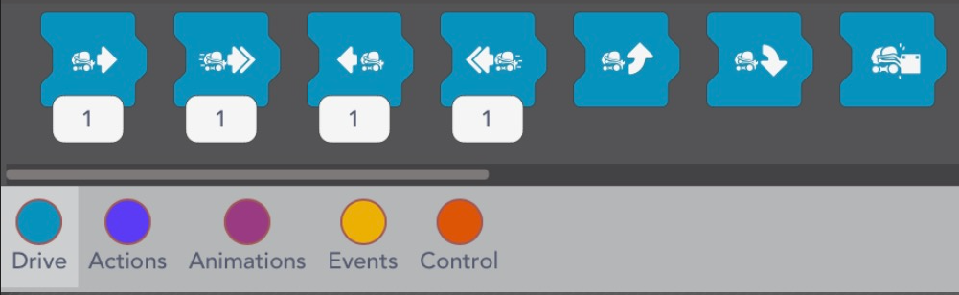

1. 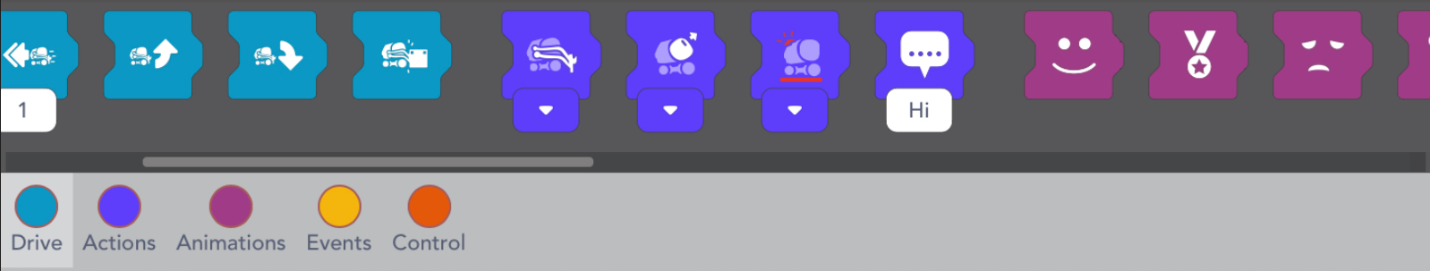Select the “Actions” tab and grab the code block shown below. Attach the block to the code.
2. Click on the drop-down tab and select the function shown below

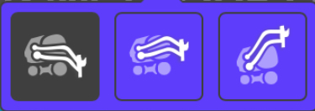

1. 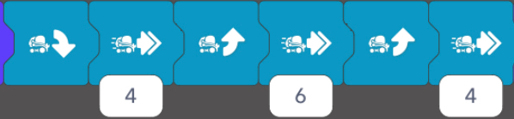Select the “Drive” tab and add the code blocks to the main code.
2. 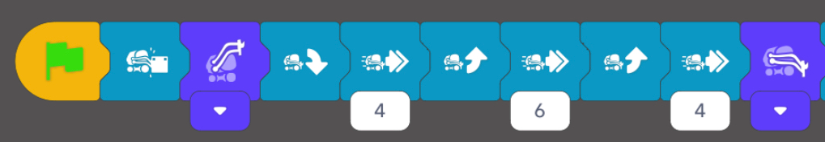Select the “Actions” tab and grab the same block as before and attach it to the main code.
3. 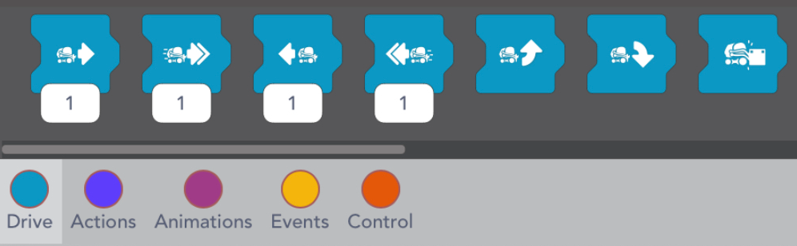Select the “Drive” tab and grab the code block below and add it to the main code.
4. Select the “Animations” tab and grab any animation you want and add it to the main code

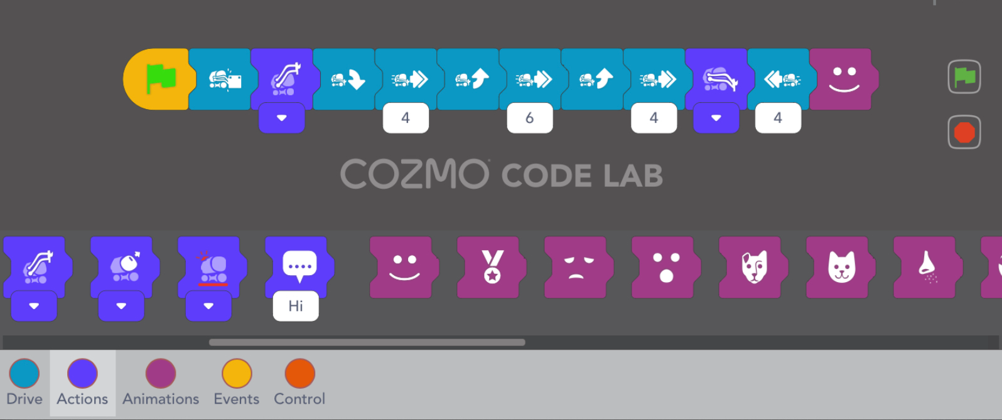

1. To test the code, click on the green flag. To stop the code while it is running, click on the red stop sign.
2. This portion will cover the maze. Under the “Drive” tab, select the first code block.

Attach it to the green flag and change the number to 4.

1. A screenshot of a phone

   Description automatically generatedA screenshot of a phone

   Description automatically generatedRepeat this and adjust the numbers until the code looks like the one below
2. Under “Drive” select the indicated code block and attach it to the end of the code

1. Select the “Actions” tab and grab the first code block
2. 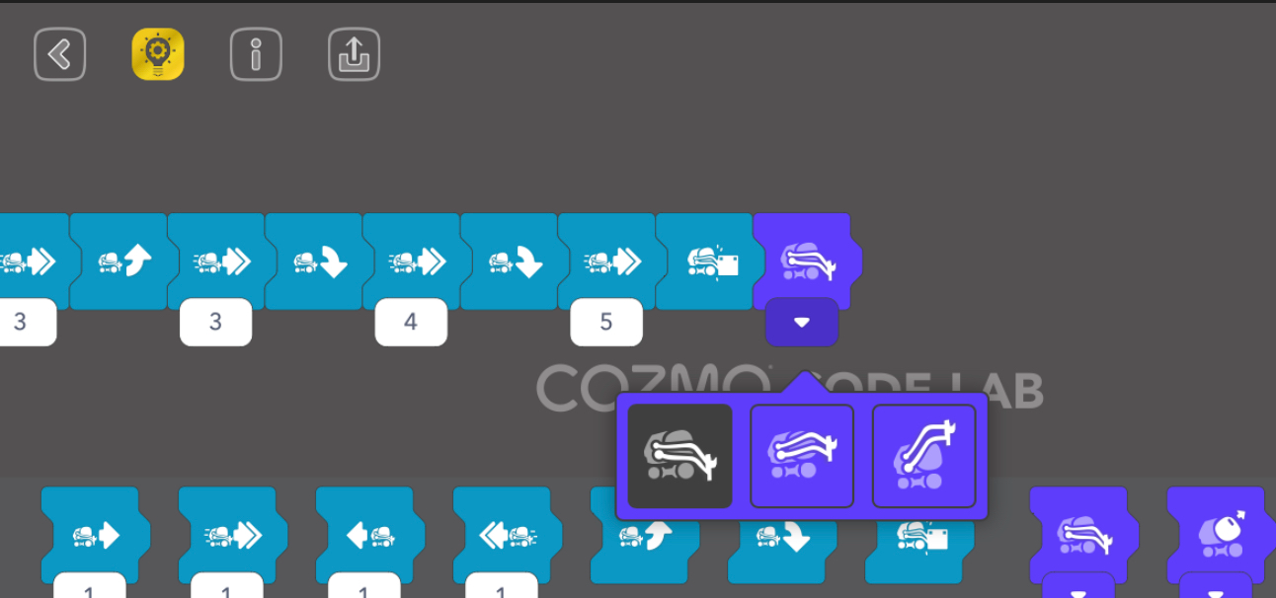Attach it to the code and click on the drop-down tab and select the last option
3. 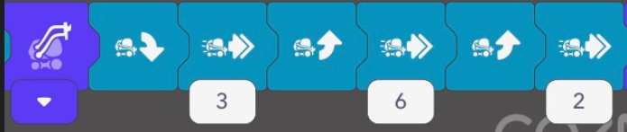Select the “Drive” tab again and add the following code blocks
4. 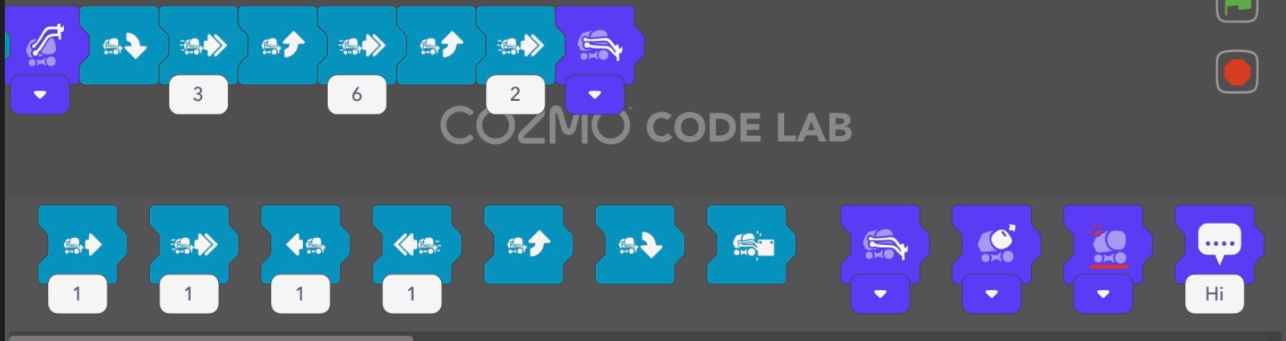Select the “Actions” tab again and grab the same code block as before and attach it to the code
5. To test the code, click on the green flag. To stop the code while it is running, click on the red stop sign.